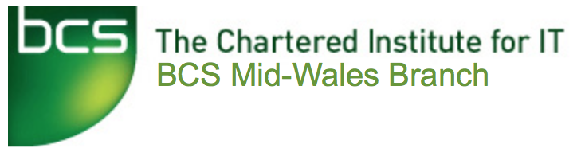

The Mid-Wales Branch Committee is committed to improving the services it provides to members. As part of this commitment we are keen to solicit your views on the meetings that we run. If you could complete this short anonymous questionnaire and return it to a Committee member, we would be most grateful. *Thank you.*

Event name: Show and Tell

Event date:

Which grade of BCS membership do you hold?

□ None □ Student BCS Member □ Associate (AMBCS)

□ Professional (MBCS) □ Fellow (FBCS) □ Corporate Member

How did you hear of the event?

□ Website □ Press □ Direct e-mail □ Word of mouth

□ Poster □ Social media □ Other (please specify)

Was the event what you expected from the publicity? □ Yes □ No (please explain)

Please comment on the strengths of this event

Please comment on any ways that this type of event could be improved in future.

Please indicate any topics that you would like to see addressed in future BCS Mid-Wales meetings.